|  |  |
| --- | --- |
|  | 16-bit Five Stage MIPS Processor |
|  |  |
|  | Jared Mann V00187636, Taylor Long V00862856  CENG 450: Computer Systems and Architecture  3/30/17 |

Contents

I. Objective 2

Abstract 2

Project Objective 2

II. Design Requirement 2

General Design Requirements 2

Instruction Set 2

Registers and Memory 2

Pipelining 2

Program Execution 2

General Implementation Choices 3

Forwarding 3

Branch Prediction 3

III. System 3

System Hierarchy Breakdown 3

System Schematic Breakdown 5

IV. Individual Module Design 5

Top Level Processor Unit 5

CPU 5

ALU 5

Muxes 5

Program Counter 5

Pipeline Registers 5

RAM Module 5

ROM Module 5

Register File 5

Control Unit 5

V. Simulation Result 5

Format A Instructions 5

Format B Instructions 5

Format L Instructions 5

VI. Analysis and Discussion 5

Hardware Verification Procedures 5

VII. Conclusion 5

VIII. Appendices 5

IX. References 5

# Objective

## Abstract

Modern processors implement pipelining to increase throughput. Many current processors implement pipelining with various stage depths having more than 5 stages such as Intel, AMD, and even current ARM processors. Pipelining is a standard across all modern architecture designs.

## Project Objective

Build a processor; using VHDL to describe the processor, and Xilinx to synthesize and implement the design on a Spartan 3E FPGA.

# Design Requirement

## General Design Requirements

### Instruction Set

The project must implement a 16-bit RISC-like instruction set. Following the format outlined on the lab website. (Dimopolous & Hazmi, 2017) The instructions are all 1-word long.

The processor must handle three types of instructions:

* A-Format (arithmetic instructions)
* B-Format (branch instructions)
* L-Format (load and store instructions)

### Registers and Memory

Registers and Memory require certain implementations:

* 8 16-bit general purpose registers, each 1-word long, with word alignment.
* A memory address space that is byte addressable.

### Pipelining

The design must implement pipelining, using a 5 stage MIPS-like pipeline. All pipeline hazards must be handled.

### Program Execution

Regarding these types of instructions, the processor must be able to execute any program written using this instruction set. All RAW and WAR hazards must be handled.

## General Implementation Choices

### Forwarding

Forwarding occurs

### Branch Prediction

Our design implements an assumption of branches being not taken.

# System

## High Level System Hierarchy Breakdown

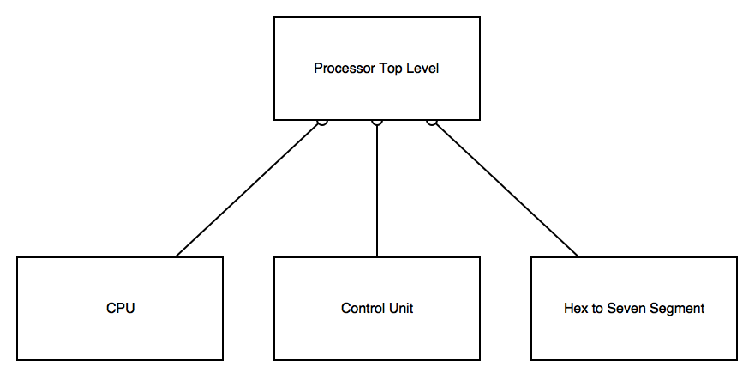

Figure 1 - System Hierarchy Breakdown

The processor is made up of a top-level file connecting the CPU, Control Unit, and Hex to Seven Segment sub-modules together. The CPU module contains its own submodules illustrated in the figure below.

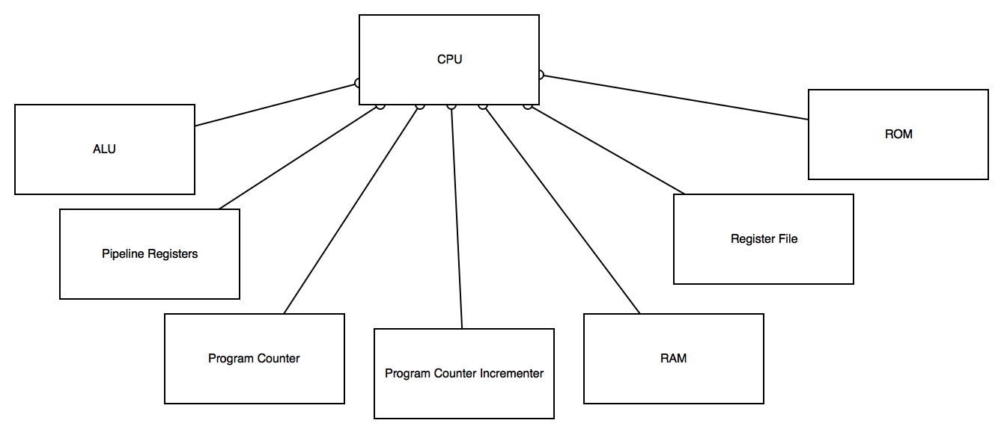

Figure 2 - CPU Hierarchy Breakdown

## High Level System Schematic Breakdown

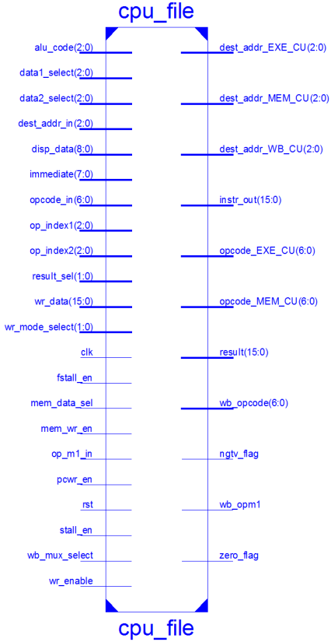

# Individual Module Design

## Top Level Processor Unit

## CPU

### ALU

### Muxes

### Program Counter

### Pipeline Registers

### RAM Module

### ROM Module

### Register File

## Control Unit

## Hex to Seven Segment Display

# Simulation Result

## Format A Instructions

## Format B Instructions

## Format L Instructions

# Analysis and Discussion

## Hardware Verification Procedures

# Conclusion

# Appendices

## Module VHDL Code

## RTL Schematics

# References